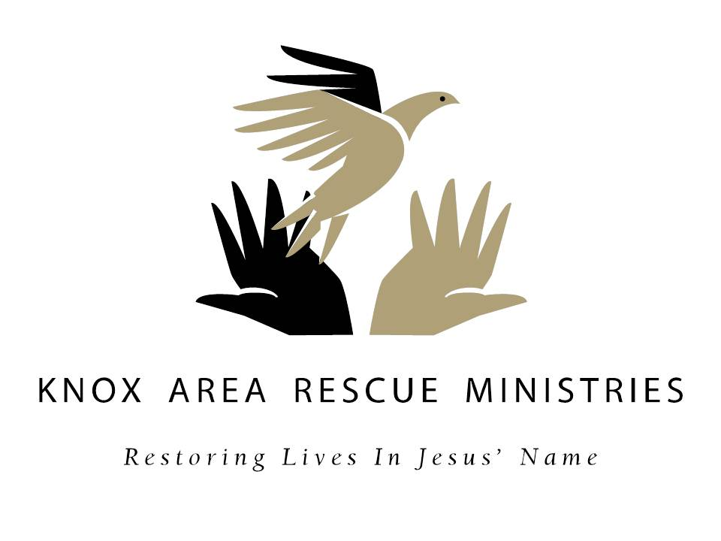
Baskets of Hope 2012
You Are Making A Difference This Thanksgiving!

Thank you for your commitment to serve our neighbors in need this Thanksgiving. This confirms our receipt of your commitment and provides the instructions you will need to shop, assemble, decorate, seal and return the groceries (along with a $10 check for the turkey) so that they can be distributed on Sun, Nov 18th. Please note the times and dates and help the ministry work smoothly and efficiently by following all the instructions.

You, your church, Sunday school class, civic club, office staff, neighborhood association, or maybe just a group of friends, will make a lasting difference in someone’s life by reaching out to them when they are at their lowest point. Instructions are detailed below:

- Print out this Confirmation/Instructions sheet.
- Pick up your box(es) at KARM on October 22-26, October 29-November 2, or November 5-7 from 9am until 5:30pm.
  - Come to KARM at 418 N. Broadway and drive around the block to the glass doors at 511 North Gay Street …Look for Baskets of Hope signs and ring door bell.
  - Take only one box for each family adopted on your Commitment Form.
- Purchase the only the following groceries which fit in the boxes:
1- 15 oz. can cranberry sauce
1-15 oz. can fruit
Total of 30 oz. canned green beans
Total of 30 oz. canned corn
Total of 30 oz. canned yams
Total of 30 oz. canned pumpkin pie mix
1- 8 oz. box instant potatoes
1- 6 oz. box of stuffing
1- 6 oz. box jello
1-1 oz. packet turkey gravy mix
  - oz. bag marshmallows

- Assemble the groceries in the Basket of Hope box (es) and seal them.
- Write a check for $10.00 payable to KARM for each box to cover the cost of the turkey. PLEASE DO NOT SEAL THE CHECKS IN THE BOXES!!
- Return the box(es) to KARM’s entrance at 511 N. Gay Street on November 8-9 from 9am until 5:30pm, Saturday, November 10 from 12pm until 3pm, or November 12-15 from 9am until 5:30pm.

We encourage you to pray for our neighbors in need and include prayers, notes or cards in your box, information on your church, or a devotional book. Be creative and decorate the box!

